Projecting NFL Wide Receiver Touchdowns Using Linear Regression

**1. Abstract**

This paper presents a linear regression model to project NFL wide receiver (WR) touchdown (TD) totals by utilizing a broad set of temporal and contextual features spanning multiple seasons. Using data from 1990 to 2024, I constructed a robust dataset that includes lagged statistics, rolling averages, player age and experience, team offensive strength, and additional ‘efficiency’ metrics. The model is trained on 1990–2010 player-seasons and tested on 2011–2024, with careful prevention of data leakage through time-bounded feature engineering. Despite the inherent volatility of touchdown scoring, the model achieves meaningful predictive performance, yielding interpretable coefficients and practical insight into WR TD scoring trends. We conclude with TD projections for the upcoming 2025 NFL season, offering actionable guidance for fantasy football participants, bettors, and analysts alike.

**2. Introduction**

Touchdowns are a key driver of value in fantasy football, Daily Fantasy Sports (DFS), and player prop betting markets. Yet among all wide receiver (WR) statistics, touchdowns are the most volatile. As a result, analysts and bettors often times find TD to be the hardest statistic to predict due to its inherent volatility.

This paper introduces a linear regression model designed to project wide receiver touchdowns using a multi-season dataset with both player-level and team-level features. Unlike models that rely solely on prior-year performance, we incorporate lag features, two-year rolling averages, age and experience indicators, and contextual team metrics such as offensive scoring and pace. This richer feature set allows the model to better account for nonlinear career arcs, regression to the mean, role changes within an offense, and changes in structure of the offense itself

The model is trained on NFL player-seasons from 1990 to 2010 and tested on data from 2011 through 2024. Our approach emphasizes temporal integrity to avoid lookahead bias: all engineered features respect chronological boundaries. Despite the simplicity and transparency of a linear model, our results show it captures meaningful signal in a noisy domain and yields actionable projections. We conclude by applying the model to 2024 data to forecast 2025 WR touchdown outcomes.

**2.1 What is Linear Regression**

Linear regression is one of the most widely used statistical techniques for modeling the relationship between a dependent variable and one or more independent variables. In our case, the dependent variable $y$ is the number of receiving touchdowns (TDs), and the independent variables $x_{1},x_{2}, …, x_{n}$ are the engineered features describing a player’s past performance, efficiency, and context (things such as like yards per game or catch rate for example)

The core idea of linear regression is to fit a straight-line (or hyperplane, in higher dimensions) relationship between inputs and output, such that the predicted values are as close as possible to the observed values. Linear Regression thus assumes:

1. The relationship between predictors and the target is approximately linear.
2. The residuals (errors) are independent and have constant variance.
3. No predictor is an exact linear combination of others (no perfect multicollinearity).

In practical terms, the model estimates how much the target variable changes (Touchdowns), on average, when each feature changes by one unit, holding all other features constant.

**2.1 Mathematical Formula of Linear Regression**

For a dataset with $n$ observations and $p$ predictors, linear regression models the target $y$ as:

$$y_{i}= β_{0}+β_{1}x_{i1}+β_{2}x_{i2}+…+{β_{p}x}_{ip}+ε_{i}$$

where:

* $y_{i}$ = the actual value of the dependent variable for observation $i$
* $x_{ij}$ = the value of predictor $j$ for observation $i$
* $β_{0}$ ​ = intercept term
* $β_{j}$ = coefficient for predictor $j$
* $ε_{i}$ = residual error for observation $i$

The goal is to find the coefficient vector $\vec{ β}= {(β}_{0},β_{1},…,β_{p}$ that minimizes the **Residual Sum of Squares (RSS)**:

$$RSS\left(β\right)=\sum_{i=1}^{n}{(y_{i}-β_{0}-\sum_{j=1}^{p}{β_{j}x_{ij})^{2} }}$$

This minimization yields the **ordinary least squares (OLS)** solution:

$$β=(X^{T}X)^{-1}X^{T}y$$

where:

* $X=n*\left(p+1\right)$ matrix of features (including a column of ones for the intercept)
* $y=n*1$ vector of target values

In the context of this paper each $β_{j}$ represents the expected change in touchdowns for a given player for a change of one-unit for the feature $x_{j}$ while assuming all other variable remain constant. Positive coefficients would imply a positive correlation between that feature and expected touchdowns scored – and vice-versa.

**3. Data Collection**

To build a model capable of projecting wide receiver touchdowns, I assembled a comprehensive dataset of NFL WR performance spanning over three decades. The dataset aggregates information from multiple sources and levels — including individual player statistics, rushing contributions, and some context about there team and situation.

**3.1 Sources**

The core data were scraped from Pro-Football-Reference.com, including:

* **Receiving stats** (e.g., targets, receptions, yards, touchdowns, yards per reception)
* **Rushing stats** (for WRs with occasional carries)
* **Team stats** (e.g., points scored, total offensive plays, yards per play)

These were compiled into season-level records for every wide receiver from 1990 through 2024.

**3.2 Feature Engineering**

To support more accurate modeling, I constructed a variety of derived features:

* **Age-based indicators** (e.g., experience, Rookie_Sophomore)
* **Team strength metrics**, like Team_Offense_Strength (points per game)
* **Efficiency metrics** such as:
  + Target_Share
  + Catch_Rate
  + TD_Per_Reception, TD_Per_Target
* **Temporal features**, including:
  + Previous season stats (TD_Prev, Yds_Prev, etc.)
  + Two-year rolling averages (TD_Avg2, Rec_Avg2, etc.)
  + Career Experience (seasons active)

All temporal features were carefully bounded by year to prevent data leakage.

**4. Methodology**

This section describes the process used to model and project wide receiver touchdown totals. The approach involves preparing the dataset, training a linear regression model and testing it on a different dataset.

**4.1 Problem Framing**

We frame WR touchdown prediction as a supervised regression task. For each player-season, the goal is to predict the number of receiving touchdowns (TD) a player will score based on a variety of contextual and historical features. The modeling target is continuous (TD ∈ ℝ⁺), and we use a linear regression framework for its transparency and interpretability.

An inherent characteristic of this modeling framework is regression to the mean: extreme touchdown totals in one season are statistically likely to move closer to league-average levels in subsequent seasons. In a linear regression context, unless a predictor perfectly explains the target, the model’s fitted values tend to be “pulled” toward the overall mean. This property helps prevent overestimation of repeat peak seasons and avoids overreacting to one-off scoring spikes, which is particularly important for touchdowns given their volatility.

**4.2 Feature Set and Target Variable**

The features used in the model fall into the following categories:

* **Lag Features**: Stats from the previous season (e.g., TD_Prev, Yds_Prev, Tgt_Prev, Y/R_Prev)
* **Rolling Averages**: Two-year rolling means for TDs, targets, receptions, and yards (TD_Avg2, etc.)
* **Player Traits**: Age, experience (Age, Age_Squared, Experience, Prime_Age, Rookie_Sophomore)
* **Efficiency Metrics**: TD_Per_Target, Catch_Rate, Target_Share, Yards_Per_Game
* **Team Context**: Offensive output per game (Team_Offense_Strength), and scoring environment
* **Durability**: Games played

The target variable is the actual number of **receiving touchdowns** scored by a player in that season.

**4.3 Temporal Validation and Data Leakage Prevention**

To ensure robust backtesting, we implement a **chronologically consistent train/test split of the data set**:

* **Training Set**: Player-seasons from 1990–2010
* **Test Set**: Player-seasons from 2011–2024

All temporal features (e.g., lag stats and rolling averages) are computed using only prior seasons up to the year being predicted. This simulates a true forward-looking forecast and ensures the prevention of data-leakage.

**4.4 Model Choice: Linear Regression**

I trained the **Linear Regression** model using scikit-learn, with the following characteristics:

* No regularization (ordinary least squares)
* Standardization applied to numeric features via StandardScaler

This choice was made to prioritize **interpretability**, making it easier to identify which features positively or negatively influence TD outcomes.

**4.5 Training and Evaluation**

We apply **5-fold cross-validation** on the training set to assess in-sample error and variance in the model. In this procedure, the training data is split into five equal parts – called folds. The model is trained on four folds and evaluated on the remaining 5th fold, repeating the process so each fold serves as the 5th evaluation set once.

**Five folds** were chosen as a balance between:

* **Bias and variance estimation** – Too few folds can yield noisy estimates of model performance, while too many folds (e.g., leave-one-out) can produce low-bias but high-variance estimates.
* **Computational efficiency** – Five folds provide stable performance metrics without making training time excessive.

Metrics reported include:

* MAE (Mean Absolute Error)
* RMSE (Root Mean Squared Error)
* R² Score

The final model is evaluated on the full test set (2011–2024) to measure out-of-sample generalization.

**5 Results and Data Visualization**

The linear regression model was trained on NFL wide receiver data from 1990 to 2010 and evaluated on a temporally isolated test set spanning 2011 through 2024. Results from the out-of-sample backtest show that the model captures meaningful signal in a high-variance target variable: receiving touchdowns.

**5.1 Top Features**

The figure below shows the features used in training and testing the model, a positive coefficient value implies a positive correlation with touchdowns (and vice-versa). A larger magnitude implies a stronger correlation.

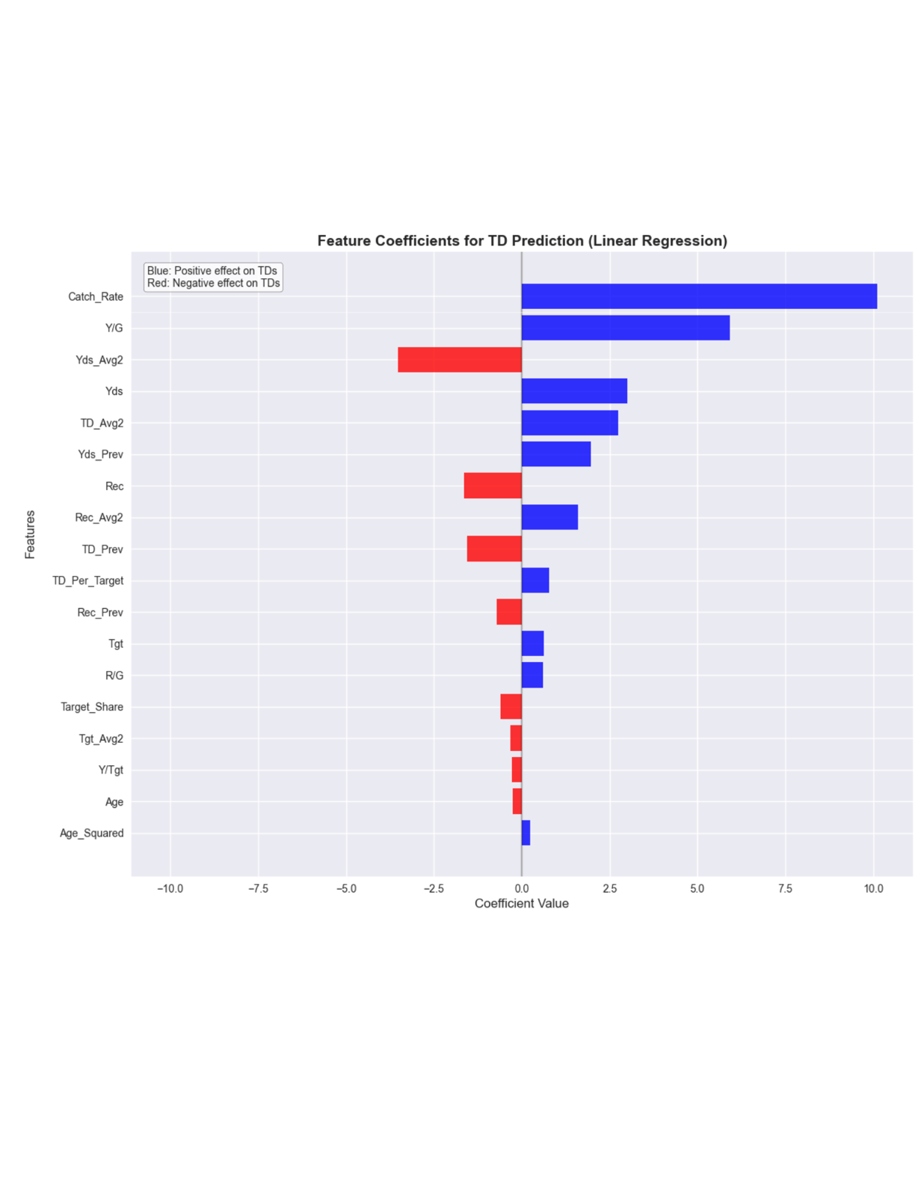

The most influential features in the model, ranked by coefficient magnitude, were:

1. **Catch_Rate** – A higher catch rate reflects a receiver’s reliability and ability to convert targets into completions. Consistently catching passes increases red-zone efficiency and scoring opportunities.
2. **Yards_Per_Game** – Sustained yardage production per game signals a player’s central role in the offense and strong target volume, both of which correlate strongly with touchdown opportunities.
3. **Yds_Avg2** – A two-year average of receiving yards. In this model, it carried a negative coefficient value. This does not mean that gaining yards is ‘bad’ for touchdowns but rather might reflect how some touchdown scorers might do some with very low yards with just a few short receptions in the red-zone that turn into touchdowns.

Notably, the model emphasizes **efficiency and sustained production metrics** over raw prior-year touchdown totals. This aligns with football intuition: touchdowns are more a product of consistent usage and high-value opportunities than of one-off high-scoring seasons. Players with reliable efficiency metrics tend to have a higher probability of maintaining or increasing their touchdown totals in future seasons.

**5.2 Test Set Performance**

The model achieves the following on the 2011–2024 test set:

| **Metric** | **Value** |
| --- | --- |
| **Mean Absolute Error (MAE)** | 0.82 TDs |
| **Root Mean Squared Error (RMSE)** | 1.29 TDs |
| **R² Score** | 0.803 |

These results indicate strong predictive accuracy for a linear model, especially given the high volatility – and perceived non-linearity of touchdowns. The low MAE suggests most predictions are within ±1 TD of actual outcomes, and the R² of 0.803 implies the model explains over 80% of the variance in WR touchdown totals.

**5.3 Cross-Validation (Train Set)**

During training (1990–2010), the model achieved a **cross-validation MAE of 0.45 ± 0.08**, suggesting low variance and good generalization. The consistency between train and test scores supports the model’s robustness and lack of overfitting.

**5.4 Data Visualization**

Predicted vs Actual TDs: Scatter plot shows close alignment with the identity line, confirming low bias.

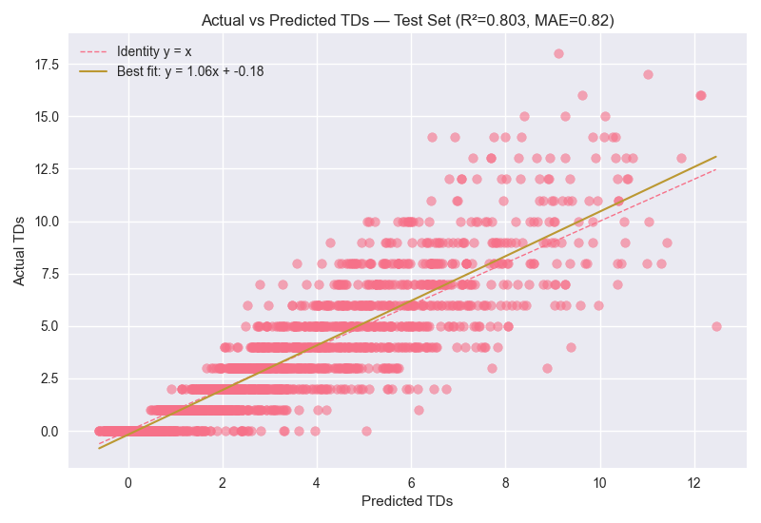

The best fit regression line is given by the equation: $y=1.06x-0.18$ where y represents actual touchdowns scored, and x represents our models projected touchdowns. Our slope being 1.06, and thus greater than 1, implies that on average our models’ projections are slightly lower. The best fit intercept is -0.18 which is very close to 0, thus insinuating minimal systematic bias.

Furthermore, what is interesting about the graph is that in comparing the models best fit line compared to the identity line (perfect predictions) we can notice a few things. When touchdowns are low (< 3) the identity line is above the models best fit line. This means that in this range of touchdowns the model slightly overpredicts touchdowns. On the contrary, when touchdowns are higher ( > 3) the identity line is below the best fit line. This means the model slightly underpredicts touchdowns, in fact the distance between the two lines increases as touchdowns increase so this under projection becomes worse as touchdowns increase (reflecting the increased variance in elite level touchdown scoring).

**5.5 Projections for Upcoming Season**

After evaluation, we apply the trained model to WRs from the 2024 season to generate **TD projections for 2025**.

Below is a table of the models projections for 2025’s top 10 TD scorers.

|  |  |  |  |  |  |
| --- | --- | --- | --- | --- | --- |
| **Player** | **Tm** | **Age** | **Games** | **TD Projection** | **TD / Game** |
| Ja'Marr Chase | CIN | 24 | 17 | 11.03 | 0.649 |
| Justin Jefferson | MIN | 25 | 17 | 9.85 | 0.579 |
| Brian Thomas | JAX | 22 | 17 | 8.52 | 0.501 |
| Drake London | ATL | 23 | 17 | 7.89 | 0.464 |
| Terry McLaurin | WAS | 29 | 17 | 7.69 | 0.452 |
| Amon-Ra St. Brown | DET | 25 | 17 | 7.4 | 0.435 |
| A.J. Brown | PHI | 27 | 13 | 7.26 | 0.558 |
| Ladd McConkey | LAC | 23 | 16 | 7.26 | 0.454 |
| Jerry Jeudy | CLE | 25 | 17 | 7.14 | 0.42 |
| Jameson Williams | DET | 23 | 15 | 7.09 | 0.473 |

These results align closely with expectations for elite WRs, with **Ja’Marr Chase** topping the list with **11.03 projected TDs**. While this is still an elite projection, it represents a **decline from his 2024 production due to reversion to the mean** — the statistical tendency for extreme performances to move closer to league-average levels in subsequent seasons.

The list includes many established stars (e.g., Justin Jefferson, Amon-Ra St. Brown, A.J. Brown) However, the model does not incorporate **external situational factors** for 2025 that could materially influence these projections. For example:

* **Justin Jefferson** and **Drake London** will be playing with new quarterbacks.
* **Brian Thomas** may see target share competition from 2nd overall pick, rookie teammate Travis Hunter.

These contextual elements, while important for interpretation, fall outside the model’s current feature set. Future work could incorporate roster changes, quarterback stability, and offensive scheme adjustments to better capture these external influences and provide perhaps more accurate projections.

**6 Discussion**

The results of our linear regression model provide several important insights into the predictability of wide receiver touchdowns and the broader dynamics of NFL scoring.

**6.1 Interpretable and Stable Performance**

The model's R² of 0.803 and MAE under 1 TD demonstrate that touchdowns, while high-variance, are not entirely random. By relying on a broad, temporally valid feature set, the model captures stable indicators of future scoring — particularly catch efficiency, receiving volume, and team context. This shows that touchdown regression and breakout candidates can be detected systematically using historical data.

Moreover, the model’s strong cross-validation performance (MAE = 0.45 ± 0.08) further validates its generalizability and lack of overfitting — particularly impressive given that linear regression makes no assumptions about interaction terms or nonlinearity.

**6.2 Feature Importance Reveals Underlying Mechanics**

The most predictive features — such as Catch_Rate, Yards_Per_Game — reflect sustainable opportunity and role in an offense rather than raw scoring alone. This aligns with the football intuition that touchdowns are often a function of consistent usage and efficiency rather than isolated high-TD seasons.

Interestingly, past TD totals (TD_Prev) did not rank among the top linear features, suggesting that surface-level regression models relying on "he scored X TDs last year" may be overly simplistic.

**6.3 Limitations**

While effective, the model does have notable limitations:

* **Linear form**: It cannot model nonlinear effects (e.g., diminishing returns, interactions between age and usage).
* **No injury or situational awareness**: The model lacks inputs for depth chart changes, quarterback shifts, or scheme alterations.
* **No red zone target data**: Red zone opportunity is a strong predictor of TDs but was not available in the dataset.
* **No adversarial defense data**: Matchups and opposing defensive strength are also omitted.

These gaps could be addressed in future work via more advanced models (e.g., tree-based ensembles, neural nets) or via richer feature sets (e.g., play-by-play data or tracking metrics).

**6.4 Practical Applications**

Despite its simplicity, the model has clear applications in:

* **Fantasy football**: Identifying WRs likely to regress or break out in TDs, which is arguably the most important stat for finding valuable players when constructing a fantasy football roster (especially in best ball fantasy tournaments)
* **DFS and betting**: Comparing model projections to prop lines to find edge.

The ability to rank players by projected TDs — and to categorize them into performance tiers — makes this model actionable across multiple domains.

**7 Conclusion**

This study developed and validated a linear regression model to forecast NFL wide receiver touchdown totals using feature-rich, temporally consistent dataset spanning 1990–2024. By incorporating lagged performance statistics, rolling averages, efficiency metrics, and team-level context, the model achieved strong predictive accuracy on an inherently volatile target variable: touchdowns.

Evaluation on an out-of-sample test set (2011–2024) yielded an $R^{2}$ of 0.803 and an MAE of 0.82 TDs, demonstrating that even in the presence of perceived randomness in scoring touchdowns, systematic patterns can be identified and exploited. The model’s interpretability allowed for clear insights into which factors most influence touchdown outcomes — with efficiency and volume metrics outperforming raw prior-year touchdown counts as predictors.

The resulting projections for 2025 offer actionable guidance for fantasy football, DFS, and player prop betting by identifying likely regression and breakout candidates. While the linear framework is transparent and robust, future work could explore nonlinear modeling, additional contextual variables such as red zone usage or quarterback efficiency, and integration of play-by-play tracking data.

In sum, this work shows that with careful feature engineering and strict prevention of data leakage, even a simple linear regression model can provide valuable and interpretable forecasts for one of football’s most volatile statistics.